CC- Develop a College Management Lightning Application to store and manage student and faculty
records. The system should ensure data accuracy using validation rules while creating or updating
records. The system should validate the following before saving:
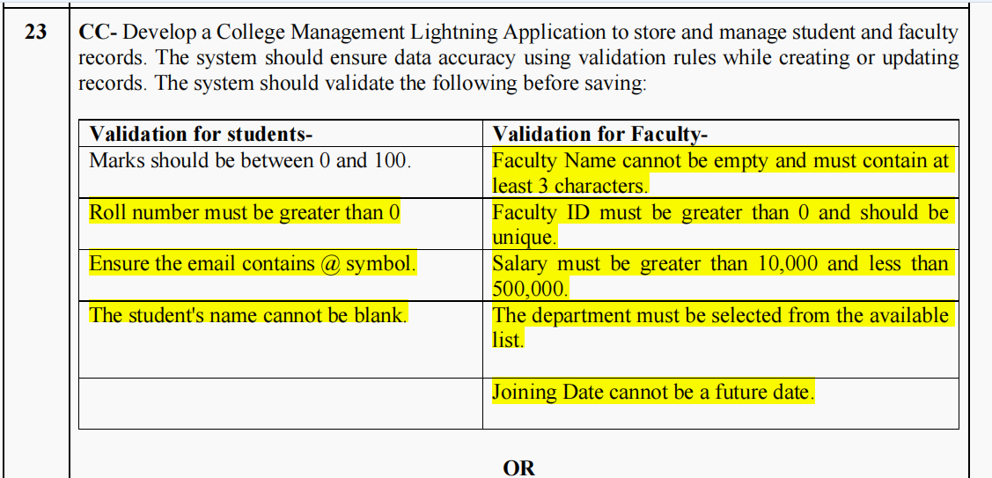

Steps:-
Step-by-Step Guide to Build the Salesforce College Management Application

STEP 1 — Open Salesforce Developer Org
First open:
Salesforce Developer Signup
Create a free account.
After signup:
- Verify email
- Login into Salesforce
Open:
Salesforce Login

STEP 2 — Open Setup
After login:
Top-right corner → Click ⚙️ Gear Icon
Then click:
Setup
Now Salesforce setup page opens.

STEP 3 — Create Student Object
Inside Setup:
Search box on left side:
Object Manager
Click Object Manager
Then:
Create → Custom Object
Fill details:
Field | Value
Label | Student
Plural Label | Students
Record Name | Student Name
Then click:
Save

STEP 4 — Create Student Fields
Now inside Student object:
Click:
Fields & Relationships
Then click:
New

Create Roll Number Field
Choose:
Number
Next
Fill:
Property | Value
Field Label | Roll Number
Length | 5
Decimal Places | 0
Next → Save

Create Marks Field
Again click:
New
Choose:
Number
Fill:
Property | Value
Field Label | Marks
Length | 5
Decimal Places | 2
Save.

Create Email Field
Again click New.
Choose:
Email
Field Label:
Email
Save.

STEP 5 — Create Faculty Object
Go again:
Object Manager → Create → Custom Object
Fill:
Field | Value
Label | Faculty
Plural Label | Faculties
Record Name | Faculty Name
Save.

STEP 6 — Create Faculty Fields
Inside Faculty object:
Go to:
Fields & Relationships → New

Faculty ID Field
Choose:
Number
Fill:
Property | Value
Label | Faculty ID
Length | 5
Decimal Places | 0
IMPORTANT:
Tick:
Unique
Save.

Salary Field
Create new field.
Choose:
Currency
Label:
Salary
Save.

Department Field
Create New field.
Choose:
Picklist
Field Label:
Department
Values:
Computer
IT
Mechanical
Civil
ENTC
AI & DS
Save.

Joining Date Field
Create field:
Choose:
Date
Field Label:
Joining Date
Save.

STEP 7 — Create Validation Rules for Student
Go to:
Object Manager → Student → Validation Rules
Click:
New

Validation Rule 1 — Marks
Rule Name:
MarksValidation
Formula:
OR(
Marks__c < 0,
Marks__c > 100
)
Error Message:
Marks should be between 0 and 100.
Save.

Validation Rule 2 — Roll Number
Create New Validation Rule.
Formula:
Roll_No__c <= 0
Error:
Roll number must be greater than 0.
Save.
Validation Rule 3 --Student Email Validation
Go to:
Object Manager → Student → Validation Rules → New
Rule Name:
EmailValidation
Formula:
If Email field type = TEXT:
NOT(CONTAINS(Email__c,"@"))
Error Message:
Email must contain @ symbol.

Validation Rule 4:- Student Name Cannot Be Blank
Go to Validation Rules → New
Rule Name:
StudentNameValidation
Formula:
ISBLANK(Name)
Error Message:
Student name cannot be blank.
Save.

STEP 8 — Faculty Validation Rules
Go to:
Object Manager → Faculty → Validation Rules

Faculty Name Validation
Formula:
LEN(Name) < 3
Error:
Faculty name should contain minimum 3 characters.
Save.

Salary Validation
Formula:
OR(
Salary__c < 10000,
Salary__c > 500000
)
Error:
Salary should be between 10000 and 500000.
Save.

Joining Date Validation
Formula:
Joining_Date__c > TODAY()
Error:
Joining date cannot be future date.
Save.
Faculty ID Greater Than 0
Rule Name:
FacultyIDValidation
Formula:
Faculty_ID__c <= 0
(Use your actual API name)
Error Message:
Faculty ID must be greater than 0.
Save.
Department Must Be Selected
Go to Validation Rules → New
Rule Name:
DepartmentValidation
Formula:
ISBLANK(TEXT(Department__c))
Error Message:
Please select a department.
Save.

STEP 9 — Create Tabs
In Setup search:
Tabs
Click:
New Custom Object Tab
Create:
- Student Tab
- Faculty Tab
Save.
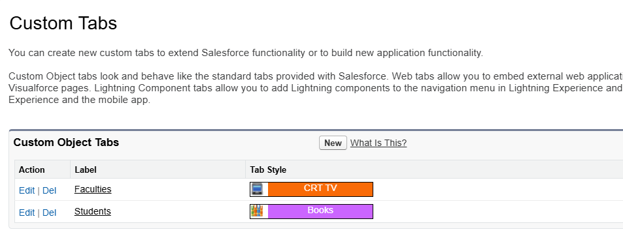

STEP 10 — Create Lightning App
Search in Setup:
App Manager
Click:
New Lightning App
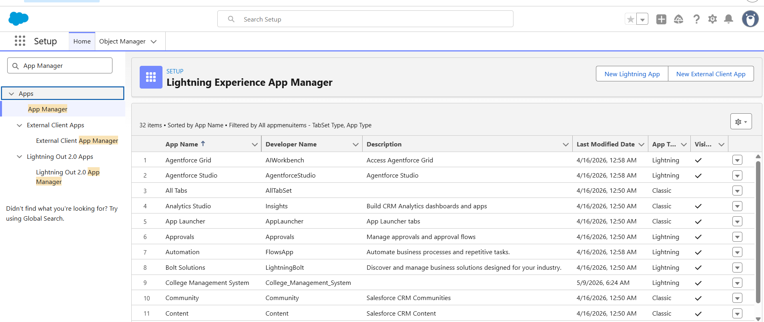
App Name:
College Management System
Next → Next → Next
Add tabs:
- Students
- Faculties
To add tabs we have to in Navigation Items
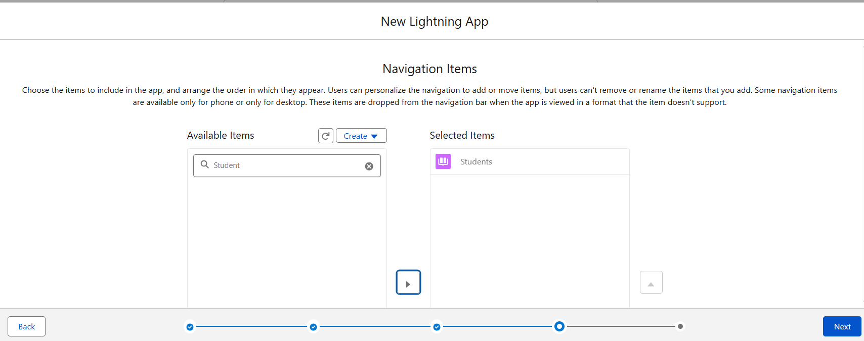
And then Go to next option which is user profile
here select system Administrator
if we will not select it then we cannt see our application okay
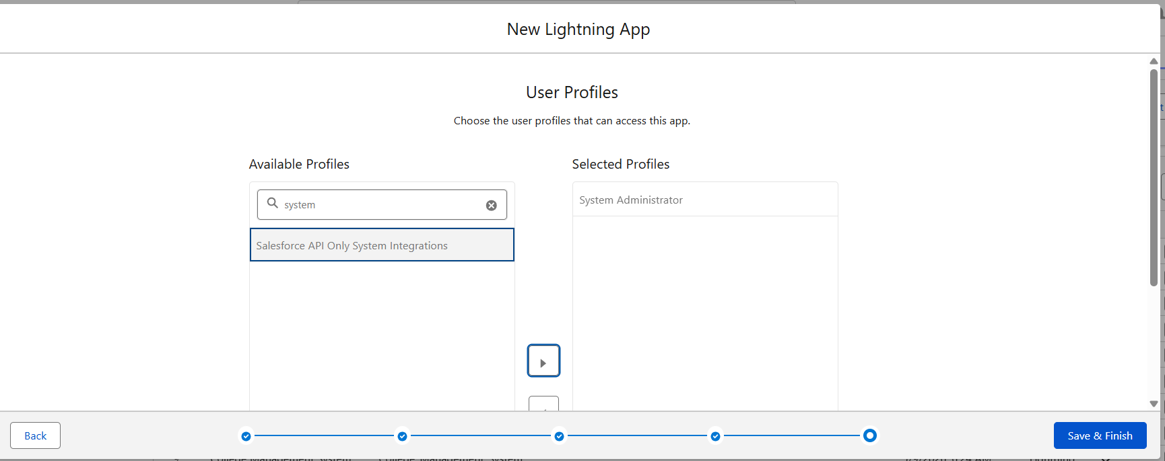
Save & Finish.

STEP 11 — Open Your Application
Top-left corner:
Click:
App Launcher (9 dots)
Search:
College Management System
Open it.
Now your Salesforce application is ready.
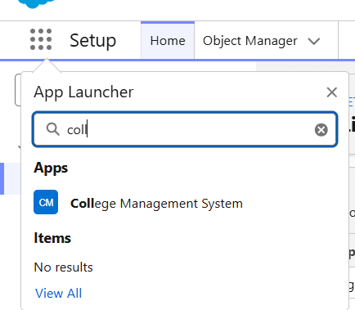

STEP 12 — Test
Try entering:
Input | Result
Marks = 150 | Error
Roll No = -2 | Error
Salary = 8000 | Error
Future joining date | Error

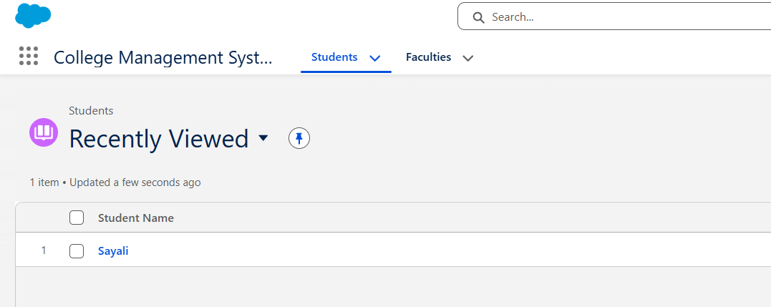
Now the Application is ready…..

